**Otto Aviation and its Phantom 3500 to Beat Carbon Neutrality Goals by 20 Years**

*At a Paris Air Show press briefing, CEO Paul Touw detailed Otto’s breakthrough technology and aircraft that enables ultra-efficient, low-emission flight*

**PARIS, June 17, 2025** — Otto Aviation, a pioneering force in sustainable aviation, held a press briefing today at the Paris Air Show where CEO Paul Touw announced the company would achieve net-zero carbon emissions with its Phantom 3500 aircraft when it enters service around 2030 – two decades ahead of the aviation industry’s net-zero carbon goal.

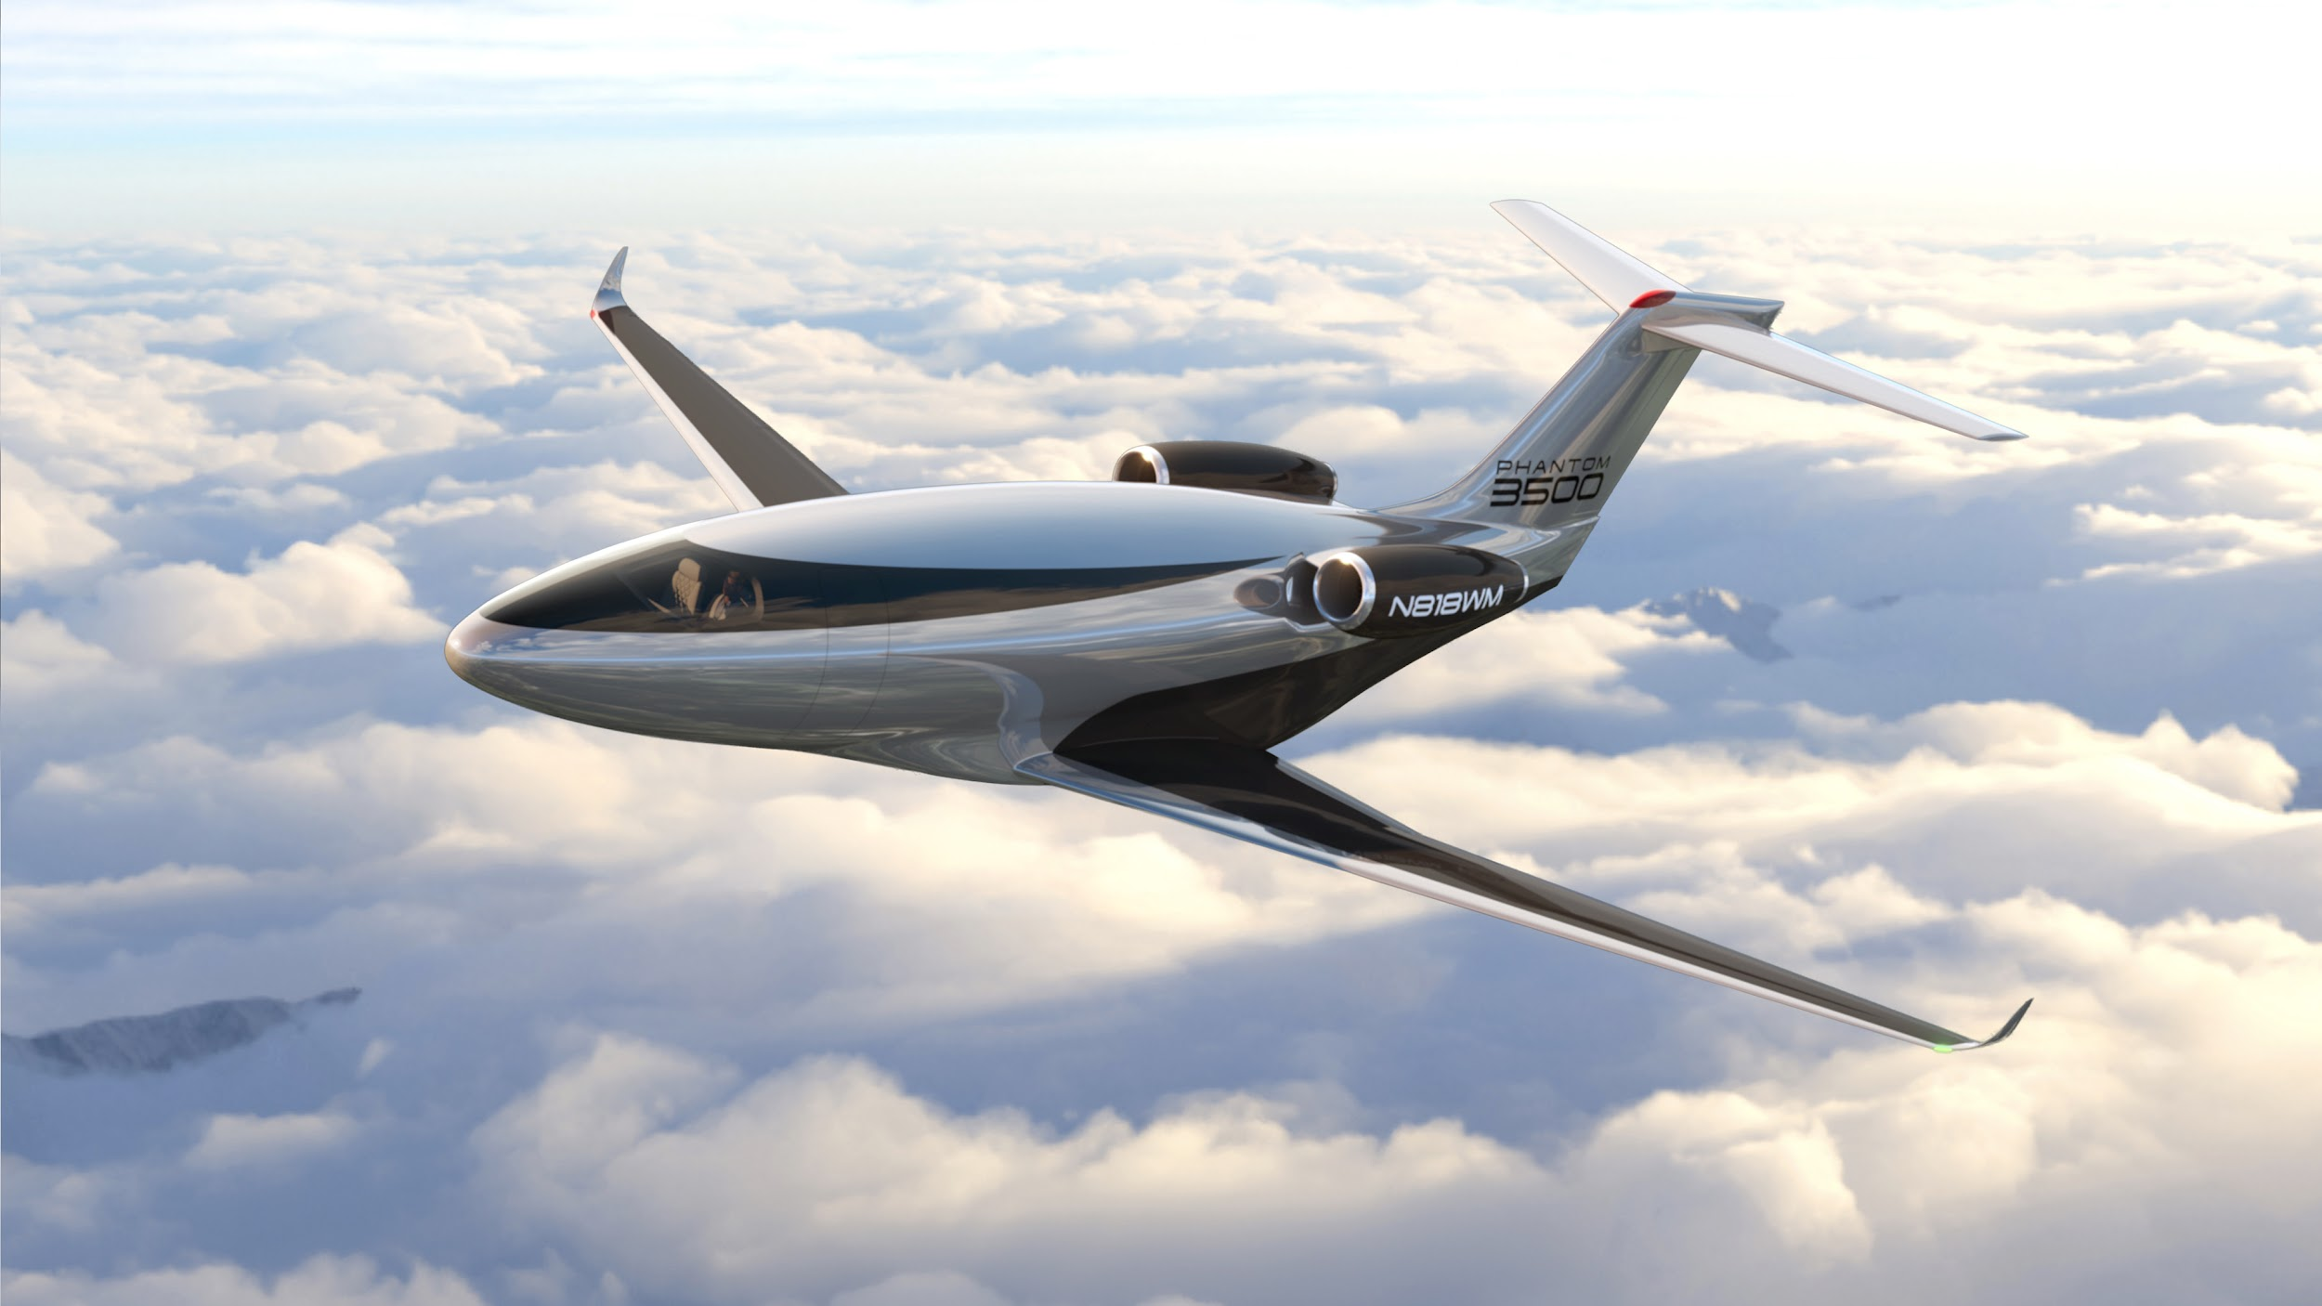

The aviation industry has set a goal to achieve net-zero carbon emissions by 2050. This goal, adopted by the International Civil Aviation Organization (ICAO) and supported by organizations like the International Air Transport Association (IATA), aims to mitigate the industry's impact on climate change by balancing CO2 emissions with equivalent amounts sequestered or offset.

Touw’s remarks took the assembled journalists and industry leaders behind the scenes of Otto’s groundbreaking aircraft, the Phantom 3500, the first true aircraft of the sustainability era. With an AI-supported clean sheet design, transonic super-laminar flow architecture, and cutting-edge aerodynamics, the Phantom 3500 is a lightweight, ultra-low-drag aircraft that burns 60 percent less fuel than similar-sized jets and reduces emissions by 90 percent when combined with sustainable aviation fuel.

“The Phantom 3500 is the result of relentless innovation and bold thinking,” said CEO Touw during his remarks. “By achieving carbon neutrality 20 years ahead of the 2050 target, we’re not just meeting expectations—Otto is redefining what’s possible in aviation. It’s a transformative step toward a future where cutting-edge technology and sustainability go hand in hand.”

On the inside, the Phantom 3500 provides space for nine passengers and has a cabin height of 6 and a half feet. In place of traditional porthole-style windows along the fuselage, the Phantom 3500 includes high-definition digital displays called Super Natural Vision™, which provides passengers with views of the sky and scenery while also enjoying increased efficiency thanks to the streamlined design.

Otto Aviation plans to manufacture the Phantom 3500 at Cecil Airport in Jacksonville, Florida, an announcement made yesterday at the Paris Air Show by Florida Governor Ron DeSantis. The company will invest approximately $430 million and move its headquarters to the city. Otto’s plan is to establish initial operations in an available hangar, then build a new plant to manufacture the Phantom 3500 on land at the airfield. The company plans to begin flight tests by early 2027, and aims to achieve certification and enter service in 2030.

**Phantom 3500 Specifications**

Mean Take Off Weight: 19,000 pounds

Basic Empty Weight: 11,700 pounds

Dimensions: 64’ W x 58.3’ L x 17.7’ H

Cabin Volume: 800 cubic feet

Cabin Height: 6’5”

Cabin Length: 23 feet

Cabin Width: 7’6”

Max Passengers: 9

Max Speed: 600+ mph

Max Range: 3,500 NM

NBAA 4 PAX Range: 3,200 NM

Cruise Altitude: 51,000 feet

Balance Field Landing: < 3,500 feet

Operating Cost: 50% less than an average Super-Mid jet

Touw is a visionary entrepreneur, engineer, and private pilot with years of aerospace experience. He previously founded and led XOJET, a disruptive private aviation company, and co-founded Ariba, a supply chain technology firm now part of the SAP portfolio. At Otto, he’s on a mission to redefine aviation through bold thinking and breakthrough design.

**About Otto**  
Otto Aviation is an advanced aerospace company committed to transforming private and regional aviation through innovative aircraft design. Headquartered in Fort Worth, Texas, Otto is developing the *Phantom 3500*, a new, clean-sheet design aircraft that establishes – and leads – a new category in highly efficient, affordable, and sustainable business jet aviation. Learn more at [ottoaviation.com](http://ottoaviation.com).

###

For media inquiries, please contact:  
Scott Worden

[scott.worden@llyc.global](mailto:scott.worden@llyc.global)

+1-248-825-9343

Or

Onsite at the Paris Airshow:

Josh Skalniak

[josh.skalniak@llyc.global](mailto:josh.skalniak@llyc.global)

+1-480-352-2050