**Otto Aviation Announces New Manufacturing Facility**

**and Headquarters in Jacksonville, Florida**

*Florida Governor Ron DeSantis announced the project today at the Paris Air Show*

**PARIS, June 16, 2025** — Otto Aviation, a pioneering force in sustainable aviation, has announced plans to establish an advanced manufacturing and production facility at Cecil Airport in Jacksonville, Florida. This strategic expansion represents a significant milestone in the development of Otto's next-generation business jet, the Phantom 3500.

The Jacksonville Aviation Authority (JAA) has approved a $34.9 million incentive package to support Otto Aviation's investment in the region and the City of Jacksonville has approved up to $20 million in a Revenue Enhancement Value grant. Additionally, the State of Florida has approved over $430 million in Corporate Income Tax Credits (CITC) and High Impact Performance Incentive (HIPI) grants to facilitate the establishment of the manufacturing plant and long term operations, which will occupy 80 to 100 acres of land at Cecil Airport.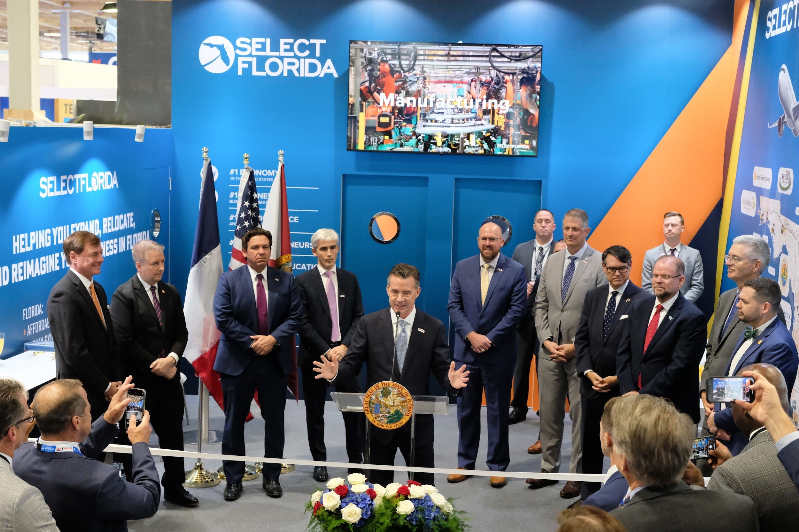

Florida Governor Ron DeSantis formally announced the project today during remarks at the Paris Air Show: "I'm pleased to welcome Otto Aviation to Jacksonville. This is a win for Florida and a testament to the kind of innovation we’re attracting. Our infrastructure and talent are primed for the next generation of aerospace manufacturing, and this project is another indicator that Florida will be home to the future of flight."

"This new facility will become more than a manufacturing site — it’s the launchpad for the future of sustainable aviation," said Paul Touw, CEO of Otto Aviation. "Jacksonville stood out as a city that shares our long-term vision: pushing boundaries in aerospace innovation while creating high-quality jobs and meaningful impact. We’re excited to become a part of this dynamic community."

Otto Aviation's Phantom 3500 is a revolutionary twin-engine business jet designed to deliver exceptional fuel efficiency, extended range, and reduced emissions. The aircraft features a full laminar flow design that cuts drag by 35% compared to traditional jets, enabling it to travel farther on less fuel. With a range of 3,500 nautical miles and a cruise altitude of 51,000 feet, the Phantom 3500 is poised to redefine the standards of business aviation.

The Jacksonville facility will serve as the primary site for the final assembly of the Phantom 3500, with production of its flight test vehicles slated to commence in 2026. The project is expected to create hundreds of manufacturing and engineering jobs, contributing to the local economy and reinforcing Jacksonville's position as a hub for aerospace innovation.

Otto plans to begin operations in Hangar 825, originally built by the U.S. Navy for aircraft fleet operations, and will subsequently develop a dedicated manufacturing plant to produce the Phantom 3500. The company's headquarters will also relocate to Jacksonville, further solidifying its presence in the region. The company plans to begin flight tests by early 2027, and aims to achieve certification and entry into service in 2030.

**About Otto**  
Otto Aviation is an advanced aerospace company committed to transforming private and regional aviation through innovative aircraft design. Headquartered in Fort Worth, Texas, Otto is developing the *Phantom 3500*, a new, clean-sheet design aircraft that establishes – and leads – a new category in highly efficient, affordable, and sustainable business jet aviation. Learn more at [ottoaviation.com](http://ottoaviation.com).

# # #

For media inquiries, please contact:  
Scott Worden

[scott.worden@llyc.global](mailto:scott.worden@llyc.global)

+1-248-825-9343

Or

Onsite at the Paris Air Show:

Josh Skalniak

[josh.skalniak@llyc.global](mailto:jos.skalniak@llyc.global)

+1-480-352-2050